Website Hacking

Revision

Day 7
Topic – Order by and Union base
How to control and combine query results in SQL.
• ORDER BY
Shows how to sort query results in ascending and descending order. Covers sorting by one column, multiple columns, and using ASC/DESC. Demonstrates how ORDER BY affects the final output of SELECT queries.
• UNION / UNION ALL
Explains how to combine results from multiple SELECT queries. Covers rules for UNION (same number of columns, compatible data types). Shows the difference between UNION (removes duplicates) and UNION ALL (keeps duplicates).

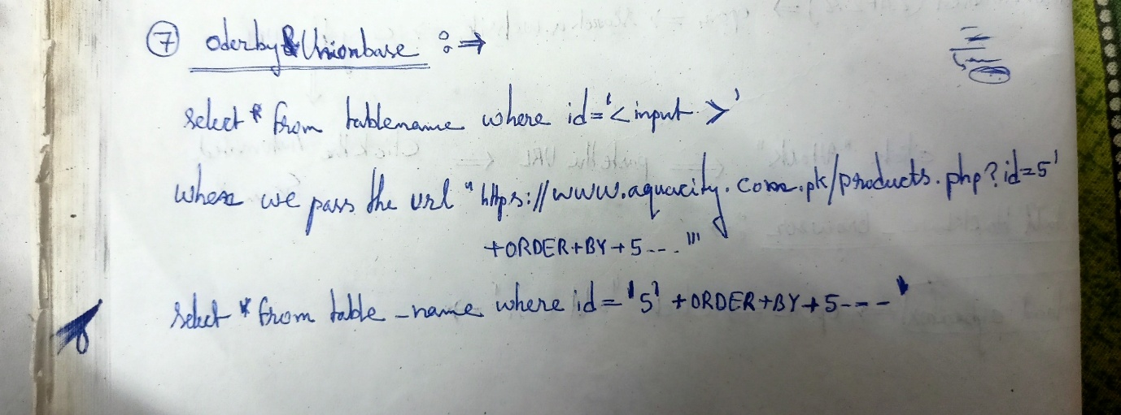

ORDER BY–based SQL injection technique. I’ll explain it clearly, but in a conceptual and defensive way, so you understand what it is and why it happens (not how to exploit sites).
- The normal situation (safe intention) A common backend query looks like this:
SELECT * FROM table_name WHERE id = '5';
The developer expects only a number (like 5) to come from the URL:
products.php?id=5
So the query should simply fetch the product whose id is 5.
- What “ORDER BY based” SQL injection means
If the application directly inserts user input into the SQL query without validation or prepared statements, an attacker can inject extra SQL.
The ORDER BY clause in SQL is normally used to sort results:
SELECT * FROM table_name ORDER BY column_name;
In an ORDER BY–based injection, someone tries to manipulate the query so the database is forced to:
• change how results are sorted
• or throw errors
• or reveal how many columns exist
This is usually used for reconnaissance, not data theft directly.
In simple words:
👉 It’s a technique to probe the database structure by abusing sorting.
- Why attackers use ORDER BY Because:
• If you order by a column number that exists, the page works • If you order by a column number that doesn’t exist, the database throws an error
From this behaviour, attackers can infer how many columns the query has.
That’s why ORDER BY injection is often an early-stage discovery method.
- What your example is showing conceptually Your note shows:
• A normal query using id = input • The URL parameter being manipulated • The backend query changing • ORDER BY being appended • The comment symbol (--) cutting off the rest of the query
Conceptually, this demonstrates:
👉 “If user input is not controlled, it can become part of the SQL syntax itself.”
So instead of being treated as data, it becomes code.
That is the core of SQL injection.
- The real lesson (most important part) This topic is not about clever tricks.
It’s about why insecure systems break.
ORDER BY–based injection happens because:
❌ Raw user input is concatenated into SQL
❌ No prepared statements
❌ No type validation
❌ No ORM or parameter binding
- How professionals prevent this in real systems, this entire class of attacks is blocked by:
- Prepared statements (most important)
Example (concept only):
SELECT * FROM table_name WHERE id =?

The database is told: “this is data, not SQL.”
So injection becomes impossible.
- Strict type validation
If id must be a number, the backend enforces it.
- ORM frameworks
Sequelize, Hibernate, Django ORM, SQLAlchemy, etc.
They parameterize queries automatically.
- Least-privilege database users
Even if a bug exists, damage is limited.
- One-line understanding
ORDER BY based SQL injection is a probing technique used to learn about a database’s structure by abusing the sorting part of a query when user input is not safely handled.

